**Capstone project -Automatic Ticket Assignment**

June 2021

Great Learning





The Real Problem

One of the key activities of any IT function is to “Keep the lights on” to ensure there is no impact to the Business operations. IT leverages Incident Management process to achieve the above Objective. An incident is something that is unplanned interruption to an IT service or reduction in the quality of an IT service that affects the Users and the Business. The main goal of Incident Management process is to provide a quick fix / workarounds or solutions that resolves the interruption and restores the service to its full capacity to ensure no business impact. In most of the organizations, incidents are created by various Business and IT Users, End Users/ Vendors if they have access to ticketing systems, and from the integrated monitoring systems and tools. Assigning the incidents to the appropriate person or unit in the support team has critical importance to provide improved user satisfaction while ensuring better allocation of support resources. The assignment of incidents to appropriate IT groups is still a manual process in many of the IT organizations. Manual assignment of incidents is time consuming and requires human efforts. There may be mistakes due to human errors and resource consumption is carried out ineffectively because of the misaddressing. On the other hand, manual assignment increases the response and resolution times which result in user satisfaction deterioration / poor customer service

Business Domain Value

In the support process, incoming incidents are analyzed and assessed by organization’s support teams to fulfill the request. In many organizations, better allocation and effective usage of the valuable support resources will directly result in substantial cost savings. Currently the incidents are created by various stakeholders (Business Users, IT Users and Monitoring Tools) within IT Service Management Tool and are assigned to Service Desk teams (L1 / L2 teams). This team will review the incidents for right ticket categorization, priorities and then carry out initial diagnosis to see if they can resolve. Around ~54% of the incidents are resolved by L1 / L2 teams. Incase L1 / L2 is unable to resolve, they will then escalate / assign the tickets to Functional teams from Applications and Infrastructure (L3 teams). Some portions of incidents are directly assigned to L3 teams by either Monitoring tools or Callers / Requestors. L3 teams will carry out detailed diagnosis and resolve the incidents. Around ~56% of incidents are resolved by Functional / L3 teams. Incase if vendor support is needed, they will reach out for their support towards incident closure. L1 / L2 needs to spend time reviewing Standard Operating Procedures (SOPs) before assigning to Functional teams (Minimum ~25-30% of incidents needs to be reviewed for SOPs before ticket assignment). 15 min is being spent for SOP review for each incident. Minimum of ~1 FTE effort needed only for incident assignment to L3 teams.

During the process of incident assignments by L1 / L2 teams to functional groups, there were multiple instances of incidents getting assigned to wrong functional groups. Around ~25% of Incidents are wrongly assigned to functional teams. Additional effort needed for Functional teams to re-assign to right functional groups. During this process, some of the incidents are in queue and not addressed timely resulting in poor customer service.

# Goal Statement

In many of IT companies,the assignment of incidents to appropriate group is done manually,which is prone to assign the ticket to wrong groups and delay in closure However, successful closure is not the only thing which matters in customer satisfaction. SLA management of incident must be managed effectively. Generally, manually assigning the management of incident must be managed effectively. Generally, manually assigning the incident has some challenges as follows:

❖ More resource usage and expenses.

❖ Human errors - Incidents get assigned to incorrect groups

❖ Delay in assigning the incidents

❖ More resolution times

❖ If an incident takes more time in analysis, other productive tasks get affected for the Service Desk



**FPO Chart or Photo**

# Objective

To resolve this issue, we are building Text classification Machine learning model by infusing artificial intelligence and Natural Language Processing capabilities. The approach is to classify into right functional group of 74 classes.

## Data Structure

Details about the data and dataset files are given in below link,

<https://drive.google.com/open?id=1OZNJm81JXucV3HmZroMq6qCT2m7ez7IJ>

Data set contains 4 columns as listed below

* Short Description: Brief description about incident.
* Description: Detailed description about incident.
* Caller: Person/Company who raised the incident.
* Assignment Group: Name of the Group of incident category.

# Column Non-Null Count Dtype

--- ------ -------------- -----

0 Short description 8492 non-null object

1 Description 8499 non-null object

2 Caller 8500 non-null object

3 Assignment group 8500 non-null object

* In above dataset ,features are Short description,Description,Caller
* In above dataset,the target is Assignment group,it is a multiclass problem
* Dataset is having a total of 8500 rows .

## Solution/Approach

This issue with the traditional approach is that it is time consuming because of the manual analysis and assignment of the incident by the team.

To resolve this issue, we are building Text classification Machine learning model by infusing artificial intelligence and Natural Language Processing capabilities. The approach is to classify into right functional group of 74 classes.

## Tools & Technology

Exploratory Data Analysis

Machine learning

Deep Learning

Natural Language Processing

Dimensionality Reduction Techniques

Libraries : Numpy , Pandas , Seaborn , Matplotlib , Scikit learn , NLTK,

Tensorflow, keras, langdetect, googletrans etc.

Algorithms : Logistic Regression , SVM , Multinomial NB, Randomforest classifier, XGBoost.



**FPO Chart or Photo**

## Business Impact/Outcome

By building automatic ticket assignment model for doing the current job

customers and company both will be benefitted. Customers will be more satisfied in terms of the quick resolution and will have less escalations. Also, company need to worry about if customer will churn in future or not.

## Quantify the Impact

From the given problem statement, we could see that the existing system is able to assign 75% of the tickets correctly. So by building an AI-based classifier model to assign the tickets to right functional groups by analyzing the given description with an accuracy of at least 85%. This will also benefit the organization not only on monitory basis but customer satisfaction will also increase which will result in goodwill of the organization.



# Leveraging AI/ML to Drive Growth and Innovation

AI Technique helps in making business process more automatic and also result in getting more accuracy in comparison to human accuracy.



**FPO Chart or Photo**

## Innovation

IT management and services are vital entities which are responsible for innovation, strengthening and increasing value, boosting productivity and giving technical services to end-users.

Although, with such profound duty front end IT conversation are considered as lengthy and tedious in terms of solving small queries like password reset, software configuration etc. Even though the service requests are genuine and crucial, support institutes often find it difficult to provide efficient services.

The manually driven task lead to bottlenecks, particularly at large institutes in form of higher resolution times and resource exhaustion. These incidents are non structured in nature and complex to be analyzed either manually or by using simple data handling techniques. Thus, Machine Learning and Deep Learning techniques can be proven useful to solve the bottlenecks by combining the traditional system with the new innovation-ticketing system.



**FPO Chart or Photo**

## Contact Details

Saurav Karmakar ([Saurav.23k@gmail.com](mailto:Saurav.23k@gmail.com))

Shivangi Jain([shivangijain666@gmail.com](mailto:shivangijain666@gmail.com))

Rajalakshmi Raveendran([rajeer20791@live.com](mailto:rajeer20791@live.com))

Krishnaveni Subramoniam**(**[krishnaveni87@gmail.com](mailto:krishnaveni87@gmail.com))

* **Overview of Solution**

To resolve this issue, we are building Text classification Machine learning model by infusing artificial intelligence and Natural Language Processing capabilities. The approach is to classify into right functional group of 74 classes.To achieve this ,we tried two approachesas listed below.However the whole project is proceeded with approach1.

**Approach 1**:As the data is imbalanced ,first we will balance data using a balancing technique, then using traditional ML algorithm we are classifying the ticket in to one of 74 assignment group

**Approach 2:**

As Grp_0 is having maximum number of records .considering only top 10 assignment group as target and using LSTM we are classifying the ticket in to one of the top 10 groups.

* **Data**

Details about the data and dataset files are given in below link,

<https://drive.google.com/open?id=1OZNJm81JXucV3HmZroMq6qCT2m7ez7IJ>

**Understanding structure of Data**

Dataset contains 4 columns as listed below:

* Short Description: Brief description about incident.
* Description: Detailed description about incident.
* Caller: Person/Company who raised the incident.
* Assignment Group: Name of the Group of incident category.

Data type of columns:

# Column Non-Null Count Dtype

--- ------ -------------- -----

0 Short description 8492 non-null object

1 Description 8499 non-null object

2 Caller 8500 non-null object

3 Assignment group 8500 non-null object

* In above dataset ,features are Short description,Description,Caller
* In above dataset,the target is Assignment group,it is a multiclass problem
* Dataset is having a total of 8500 rows .
* Dataset seems to have few missing /null values in columns Short description and Description need to be looked and handled
* Inorder to ensure we are not missing any information needed for classify ,we need to concatenate the columns Short description and Description in to a Single column
* Caller column is holding only the details regarding the user who raised the incident so its not having any significance so it can be dropped

# EDA (Exploratory Data Analysis)

* There are Four columns – Short Description, Description, Caller and Assignment group.

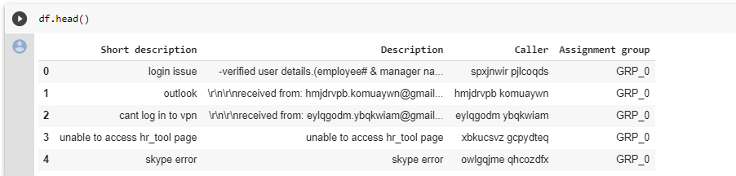

* Total 8500 entries



* Total Unique 74 Assignment groups found - Target classes



* Multiple languages found (eg: English, German, etc.)

Ref: Below shown is the German word from the dataset along with English words. ~82 % are English words.

As per language detect library, there are total 29 languages in the Description column of the given dataset.

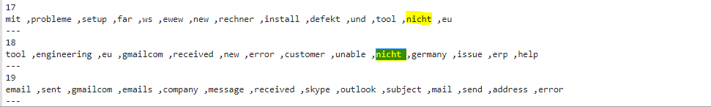

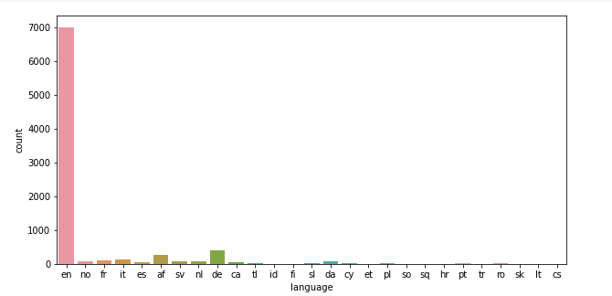

* Description column observation:
  + Email/chat format in description
  + Symbols & other characters in the description
  + Hyperlinks, URLS & few image data found in the description
  + Blanks found either in the short description or description field
  + Few descriptions same as the short description
  + Few words were combined
  + Duplicate data observed.

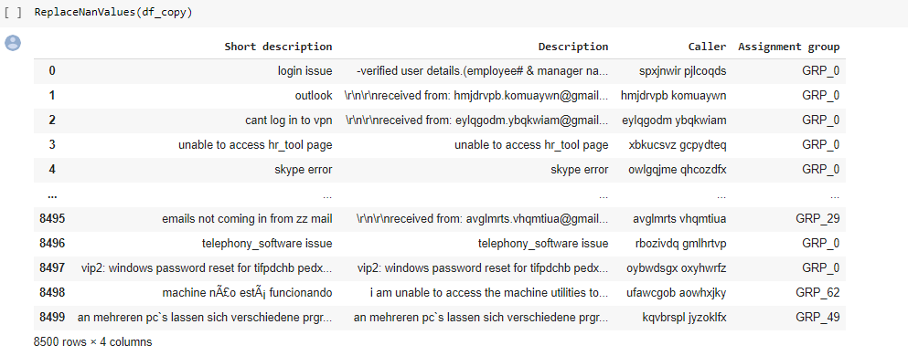

* Large no of tickets is assigned to GRP_0 (amounting to 3926) which account for ~50% of the ticket assignment.

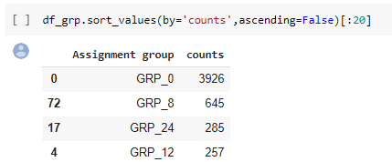

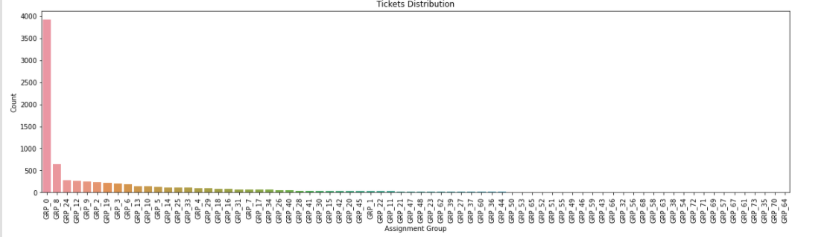

* As seen in the fig above, the Target class distribution is extremely skewed

* Presence of duplicate data: There are total 83 duplicate entries in the given dataset. We have combined short description and description column which helped in getting duplicate entries based on combined data.

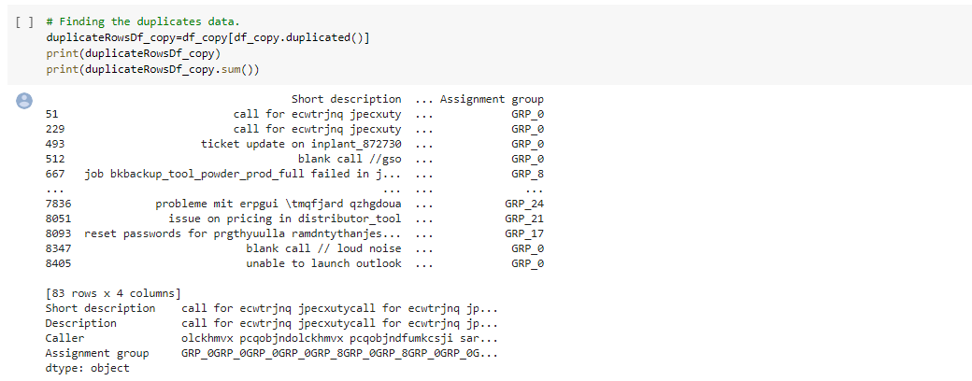

**Analysis of target column Assignment group**

* Swarm plot – From the below plotted graph it can be ascertained that  Group-0 has highest count in terms of assigned tickets.

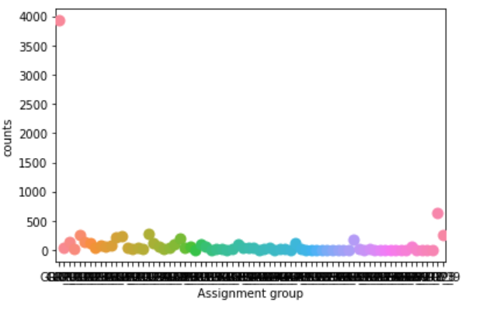

**Distribution of tickets in dataset based on assignment groups**

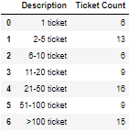 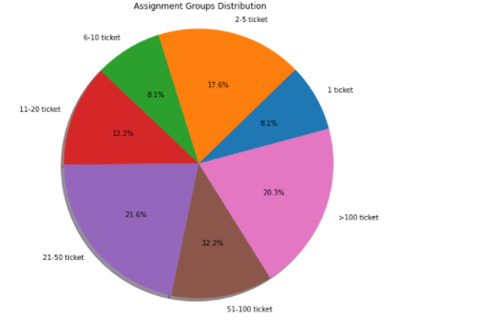

* There are 6 groups having only 1 ticket
* We are having only 15 out of 74 groups having more than 100 tickets.
* Visualisation using word cloud
* Word Cloud – Word cloud Function is used to visualize most frequent words present in data set after processing data through various cleaning functions like, stop word removal, punctuation removal e.t.c

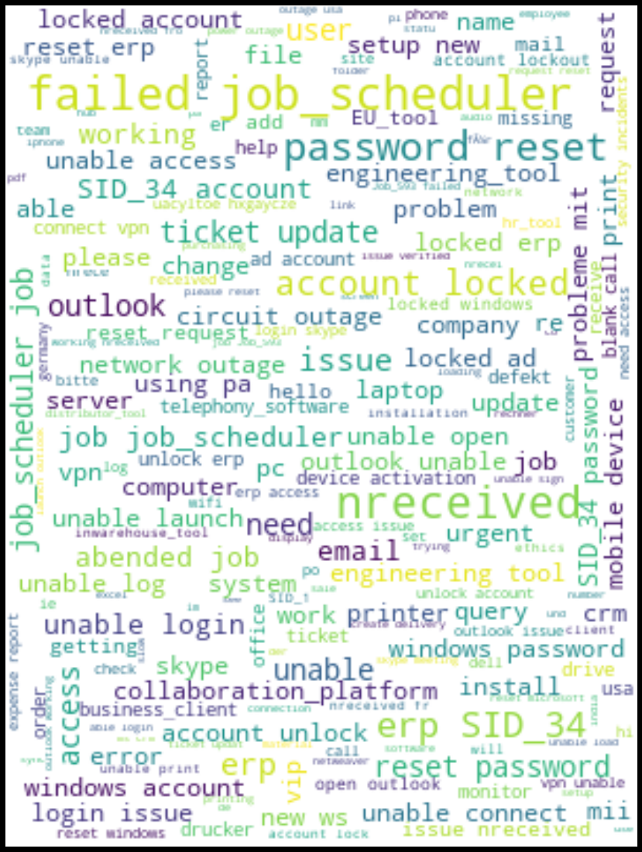

In above word cloud, we can observe that "password reset" , "ticket update" , "account locked",job_scheduler are most frequently raised incident

**Word cloud for GRP_0**

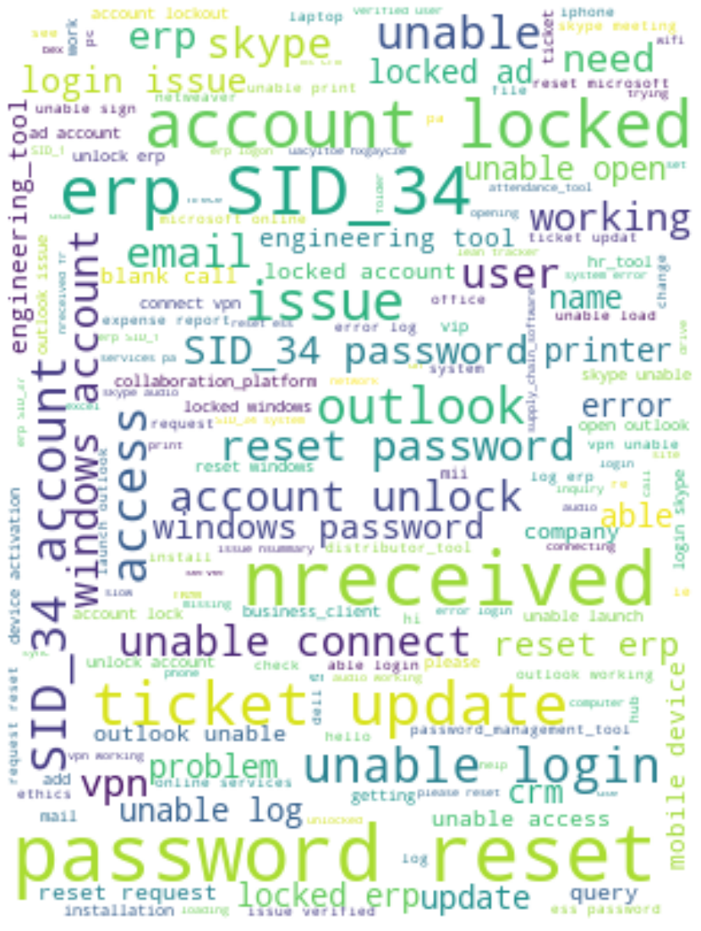

In GRP_0, we can observe that "password reset" , "ticket update" , "account locked" are most frequently raised incident

# Data Pre-Processing steps

* Cleansing dataset as follows:
* Removed duplicates data using functions.

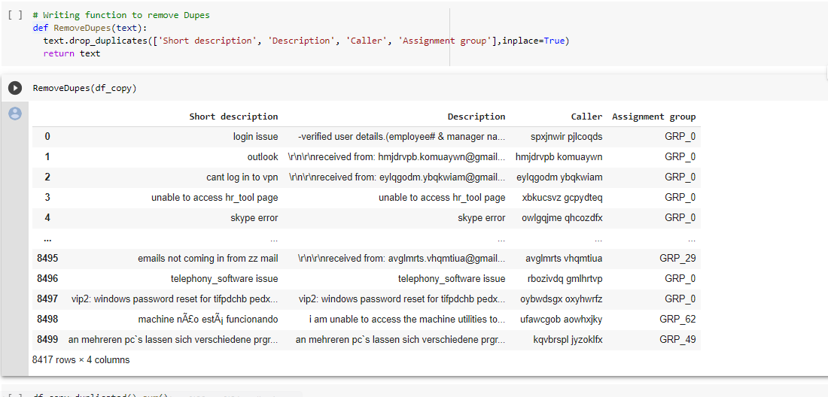

* Merging Short Description and Description



* Removing null values:
  + Before replacing null values:

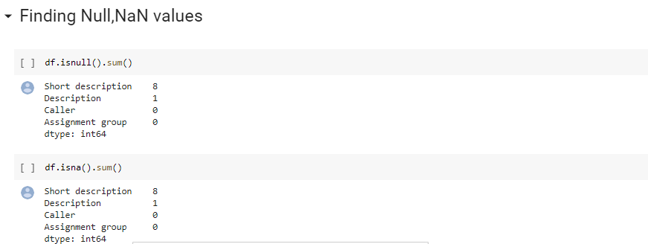

* + After replacing null values:

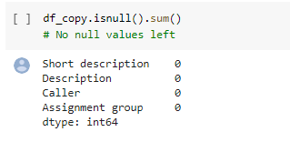

* Multiple language | language detection | language translation



Multiple languages present in dataset. Also, maximum incidents are in ‘English’ language. So we can convert remaining languages to English. We have used langdect library to detect language and googletrans to translate language to English.

* **Data Cleaning | Lemmatization | Stopwords**

**Data Cleaning** : Function data_clean_up() has been created to clean up the unwanted information from dataset. This function removes html tags,accented texts,punctuations,email words,special characters,convert all to lower case,white space ,extra space,unreadable characters,hyperlink etc.

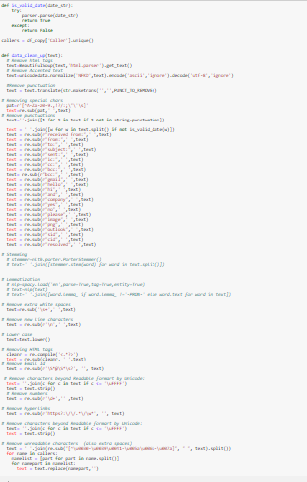

**Data before cleaning up**



**Data after cleaning up**



* **Lemmatization:**

Lemmatization is technique to reduce inflected words to their word stem. It makes sure the root word (also called as lemma) belongs to the language. Lemmatization is slower than Stemming (another technique to reduce inflected words to their root. WordNetLemmatizer in nltk is used to lemmatize the sentence.

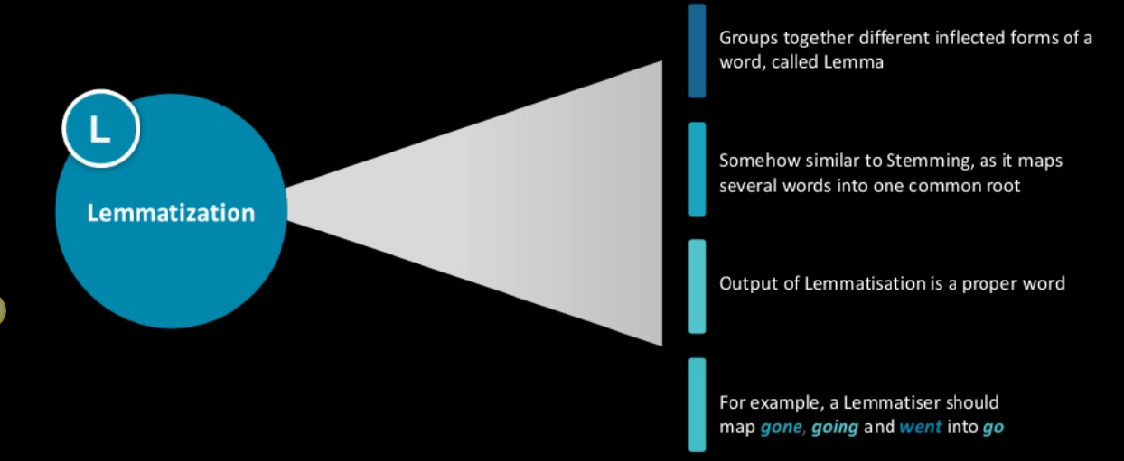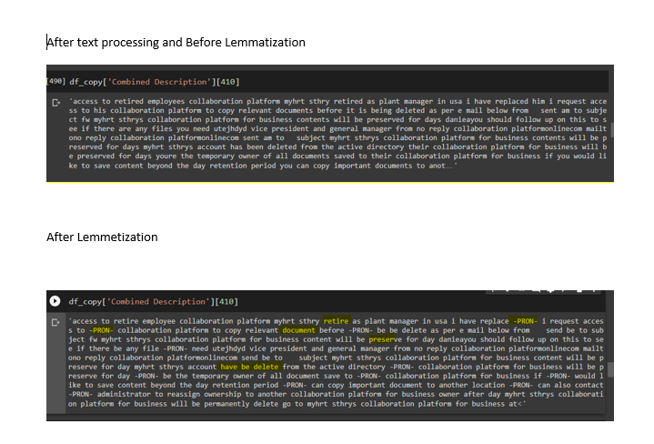

* **Stopwords :**

Stopwords are commonly occurring words in a language like 'the', 'a' and so on. They can be removed from the text most of the times, as they don't provide valuable information for downstream analysis. In cases like Part of Speech tagging, we should not remove them as provide very valuable information about the POS. But in this project, we are not using POS and hence removing it.

* **Visualization using Wordcloud after Data cleaning and pre-processing**

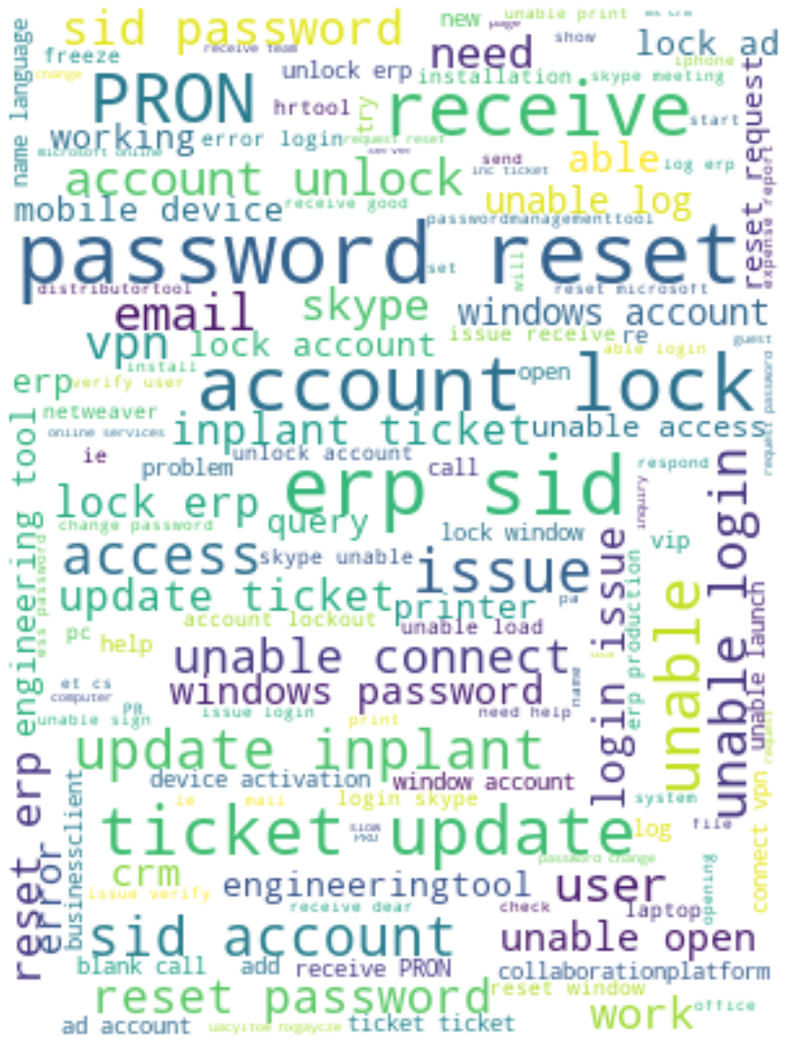

Now we can visualize data clearly after data cleaning and text preprocessing.

* fast Text – Semantic similarity between words.

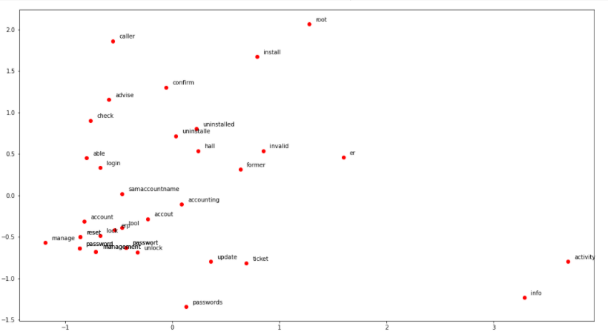

* Vectorizing the corpus

I have used TFidfVectorizer for vectorizing the corpus. **TF-IDF** is a statistical measure that evaluates how relevant a word is to a document in a collection of documents. This is done by multiplying two metrics: how many times a word appears in a document, and the inverse document frequency of the word across a set of documents.

* Deciding model and Model building

The issue is a multi-class classification problem so we need to classify the tickets among one of the available assignment group.

Topic modeling

Topic modeling is a method for **unsupervised** classification of documents, similar to clustering on numeric data, which finds some natural groups of items (topics) even when we’re not sure what we’re looking for.

I have used **LDA (Latent Dirichlet Allocation)** to generate the topic model. It is one of the most popular topic modeling methods. Each document is made up of various words, and each topic also has various words belonging to it. The aim of LDA is to find topics a document belong to , based on the words.

Benchmark model

We have used Traditional Machine Learning Classification Models Logistic Regression, MultinomialNB, Random Forest, SVC, XGBoost Classifier .

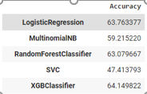

As in the above the accuracy which we got is very less .so we have done hypertuning for those to get a better accuracy

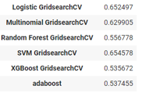

Inference : After hyper parameter tuning also, we are getting less accuracy. Since it is a case of imbalanced dataset, we have used random oversampling technique.

Handling Class imbalance

**Random oversampling** involves **randomly** selecting examples from the minority class, with replacement, and adding them to the training dataset.

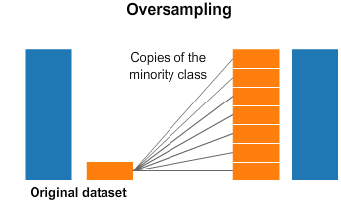

Below are the accuracies we have got after using random oversampling techniques

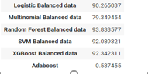

Here we can see that accuracies are improved drastically .After handling imbalance we are able to achieve 93.8% accuracy for Random forest classifier .so we decide to take this model further.

* **Fast Text:**

Fast-Text is a library for learning of word embeddings and text classification created by Facebook's AI Research lab. The model allows one to create an [unsupervised learning](https://en.wikipedia.org/wiki/Unsupervised_learning) or [supervised learning](https://en.wikipedia.org/wiki/Supervised_learning) algorithm for obtaining vector representations for words. Facebook makes available pretrained models for 294 languages.

It gives semantic similarity between words.

***Fast Text Model Approach:***

1. Fast-Text Libraries Downloaded.
2. Assignment Group text changed to Fast text format i.e. _label Groups respectively.
3. Columns Taken Assignment Groups and Combined Description.
4. Train and Test Data divided.
5. Fast-Text Supervised trained model.​
6. Test the model on created Bin file on Test Data.

|  |  |  |  |  |  |
| --- | --- | --- | --- | --- | --- |
| **Train Data** | **Test Data** | **Number of Labels** | **Precision** | **Recall** | **Loss** |
| 7000 | 1408 | 74 | 57.5 % | 57.5 % | 2.0118 |

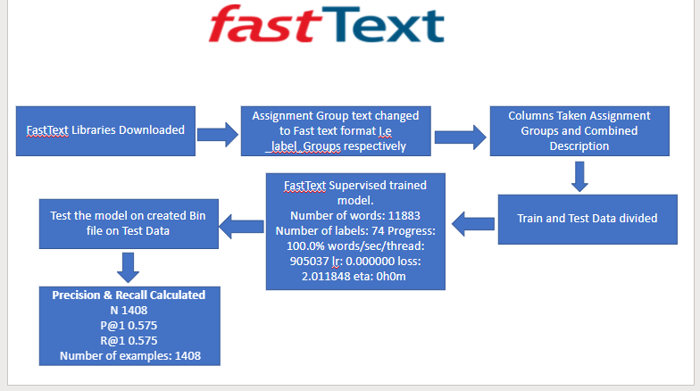

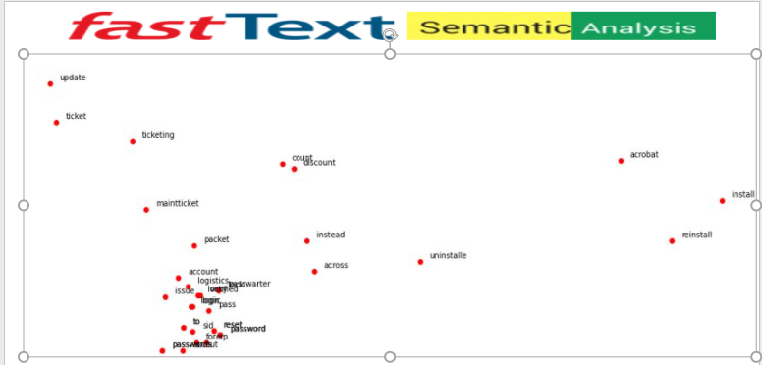

# Cloud Application (Model Deployment)

We have created a cloud application using a dev stack having backend which is being served by a “Flask Application” and UI on “ReactJS”. Deployed on an AWS EC2 instance with instance type t2.2xlarge DLAMI

Which is equipped specially for Data Science processing.

Backend –

* Flask application with two endpoints

{

    "combined_string": "Short DescriptionDescription",

    "desc": "Description",

    "model_summary": "Model: \"sequential\"\n________________________________________________________________________________\nLayer (type)                        Output Shape                    Param #     \n================================================================================\nembedding (Embedding)               (None, 250, 200)                2622000     \n________________________________________________________________________________\nbidirectional (Bidirectional)       (None, 200)                     240800      \n________________________________________________________________________________\ndense (Dense)                       (None, 74)                      14874       \n================================================================================\nTotal params: 2,877,674\nTrainable params: 2,877,674\nNon-trainable params: 0\n________________________________________________________________________________",

    "predicted_class": "17",

    "short_desc": "Short Description"

}

UI –

* ReatJS application which two form fields taking the short description and description, using the POST call to the backend sending the fields data to the API. Response will have the model summary and predicted class as a JSON data which is then consumed by the react app to show on the UI.

# Implication:

After understanding the problem, the major issue of existing ticket system is that almost **25%** tickets are wrongly assigned to respective groups and that result in re-assigning of tickets and sometime missing the SLA. Additional effort is applied to re-assigning the ticket.

 To cater this problem, with the help of ML/AI-Natural language processing, existing ticket assignment data is pre-processed, exploratory data analysis done, Regex, text cleaning, word computation and NLP techniques applied to construct few models that can accurately predict re-assigning of tickets.

There were quite few models in race, for example: **Fast-text**, **Bidirectional LSTM**, Naïve Bayes, SVM and Random Forest.

However, on the basis of better precision, recall and accuracy we have gone ahead with two model’s Bidirectional LSTM and Fast-Text to further improve the Accuracy by applying hyper parameter tuning.

**There were certain parameters that were considered**:

1. Reducing the dataset to top 10 and 5 groups as data is imbalance.
2. Hyper parameters like Epochs, learning rate have helped in improving accuracy.

Finally, we are able to get accuracy for Bidirectional LSTM as **96.5 %** and for Fast-Text as **90.4 %.**

This means that our Automatic ticket system has error rate of less than **5 %** if we choose our best model which is far more less that existing error rate of **25%** while assigning the ticket.

So, level of confidence **is 96.5 %** and this model will also eradicate manual intervention of assigning the tickets to respective team.

# Project Scope :

* 1. As we understand from data that its imbalanced as Group-0 Contains more than 50% of the records. Hence this imbalance of data makes difficult in prediction for the group that have very less ticket assignments.
  2. As part of Data pre-processing, we had grouped all assignment groups (top_10_grp) with less than 10 entries as one group which had reduced the Target class from 74 to 10 groups. While applying this model in the real world there could be additional intervention required to classify the tickets if it has been classified as top_10_grp by our model. Since the number of elements reported under top_10_grp, are less, we expect this intervention to be done less often.
  3. We have translated our data to English language only.
  4. In general business scenarios, the volume of data will be more, whereas here we considered only 8k data for our analysis, this could be a limitation in terms of predicting the things, when we have more data in production.

# Closing Reflections:

While working on problem statement, we learned about many things.

* + Understanding the data.
  + Data distribution and type.
  + Preprocessing of data.
  + Exploratory Data analysis.
  + Text cleaning and translation.
  + Feature engineering.
  + Visualizing the data.
  + Semantic analysis.
  + Word cloud.
  + Implementing models like Fast text, LSTM, SVM, Naïve Bayes, Random Forest.
  + Hyper parameter tuning.

**Future Scope:**

* + Executing model on balanced data and large dataset.
  + Executing model on multiple language dataset.
  + Experimenting with different models like BERT etc.